Document Development Environment Setup Exercise

Trey Williams
University of the Cumberlands
MSAI-631-A01: Human-Computer Interaction.
Dr. Alan Dennis
August 30, 2026

Document Development Environment Setup Exercise
This exercise was conducted to create a Python development environment and integrate it with the course GitHub repository. I selected Google Colab because I am already familiar with the Google ecosystem and because it supports Python, common development libraries, and GitHub integration. Kore (2022) describes artificial intelligence from a rational-agent perspective, in which intelligent systems attempt to take appropriate actions despite limited information or resources. This perspective provides a useful framework for evaluating development tools not only by whether they function technically, but also by how effectively they help the user accomplish a specific goal.
Selection of Google Colab
Google Colab was a practical choice because I was already familiar with other Google products and AI tools. Since Colab is browser-based, I did not need to install or configure a local Python environment, which reduced setup time and allowed me to begin coding immediately. Artificial intelligence draws on multiple disciplines, including computer science, mathematics, psychology, economics, and engineering (Kore, 2022). Colab reflects this interdisciplinary nature by bringing together programming, data analysis, machine learning libraries, and AI-assisted development in a single environment.

Figure 1
Establishment of Google Colab
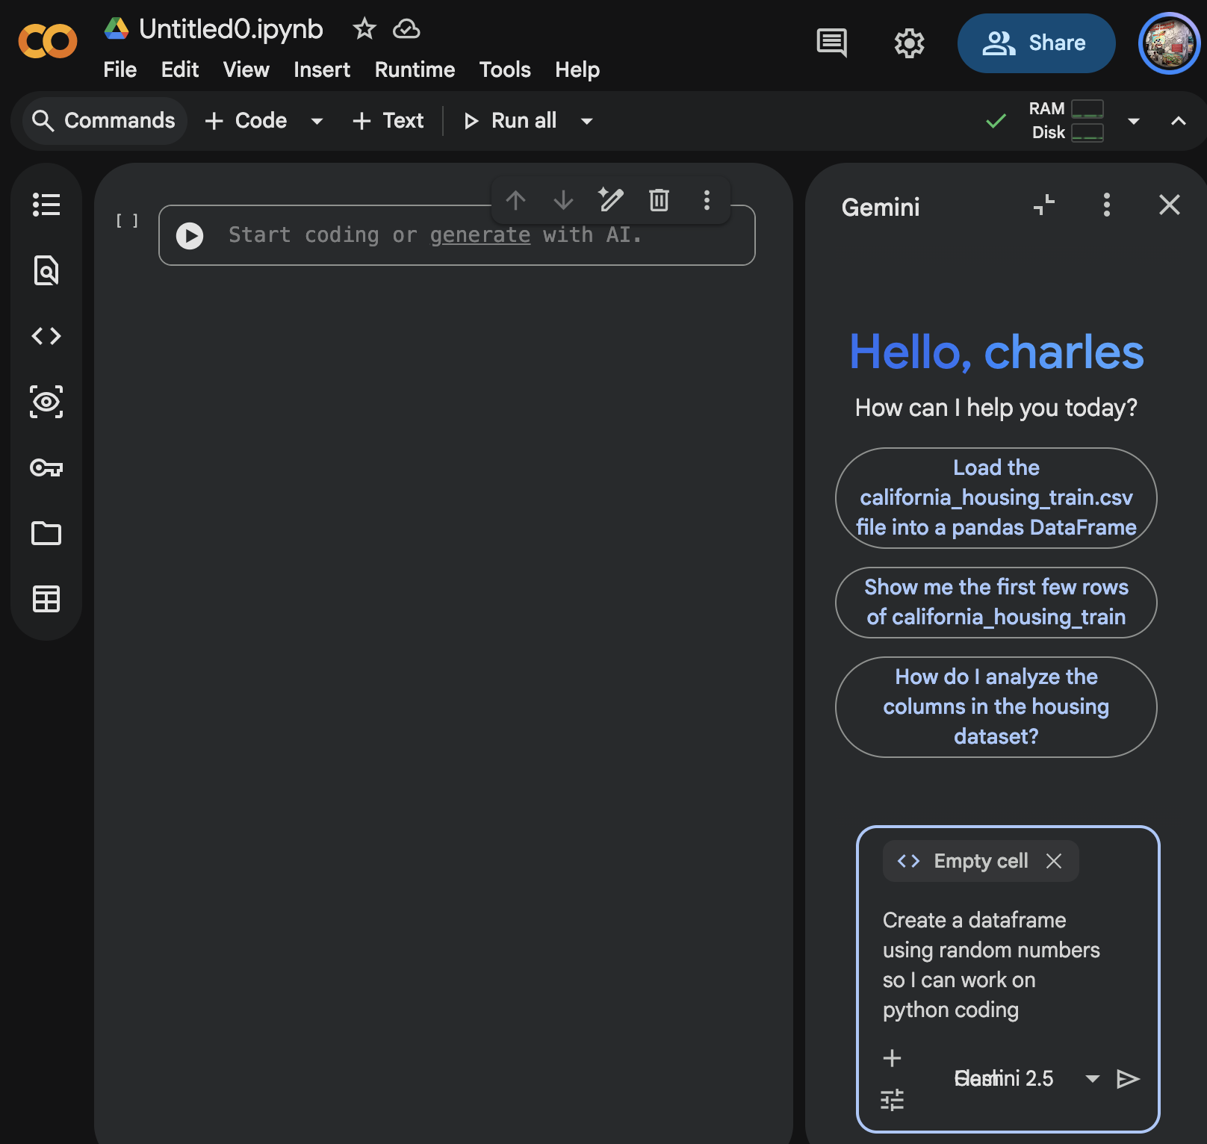
Testing the Development Environment
After creating the new notebook, I renamed it to MSAI631_Development_Environment and tested the Google Gemini integration by generating a random number DataFrame. The code imported the required libraries, created the DataFrame, and displayed the results, confirming that the Python code could execute successfully and that the notebook supported the necessary libraries and output functions. I then manually entered and ran a simple print("Hello World") statement, which also executed successfully. Kore (2022) explains that real-world intelligent systems operate under limitations involving information and computational resources, which reinforces the importance of validating that a development environment can reliably execute code and support the tools required for the task.
Figure 2
Testing Python Libraries and DataFrame Creation in Google Colab
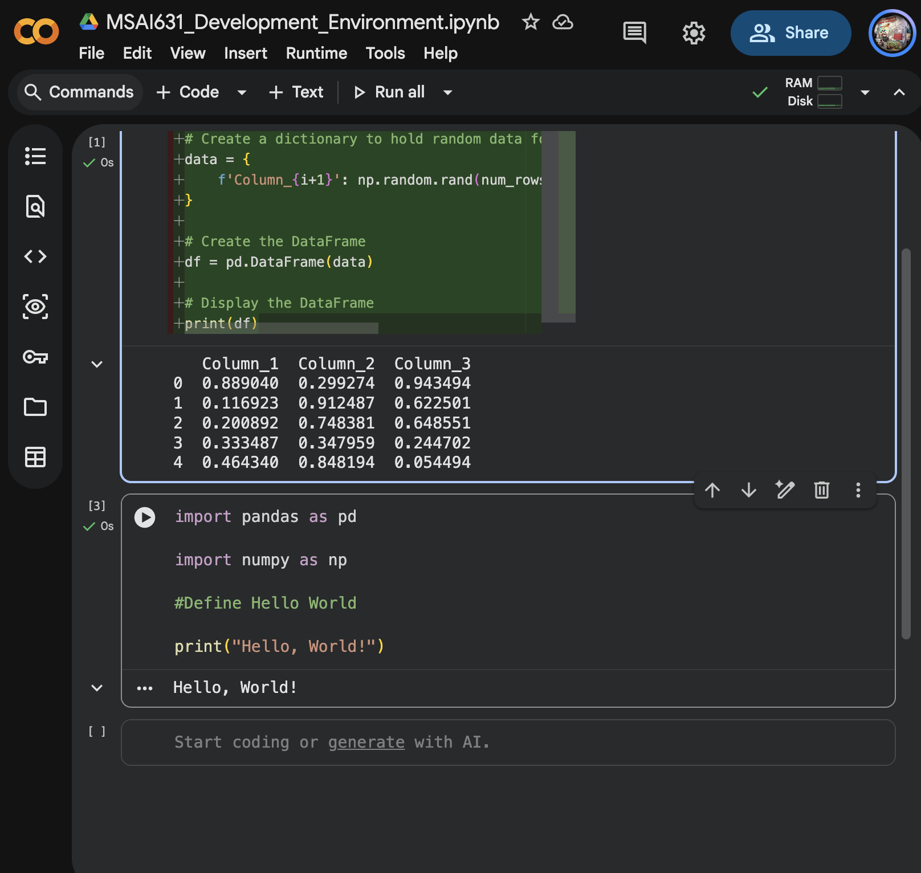
GitHub Integration
The next step in the assignment was to integrate the development environment with GitHub. In Google Colab, I selected File, then Save a copy in GitHub, chose the MSAI 631 repository I had created in the previous assignment, and saved the notebook. I then opened GitHub separately and confirmed that the notebook appeared in the correct repository. AI and software development rarely occur in isolation; they depend on collaboration among people with different technical and organizational roles (Kore, 2022). GitHub supports this collaborative process by providing shared source-code storage, version control, and a common environment for managing project files.
During the GitHub integration process, I encountered an issue: the MSAI 631 repository did not appear as an available option in Google Colab. I first reviewed the authorization settings and repository permissions, but those changes did not resolve the issue. After several minutes of troubleshooting, I determined that the repository’s private visibility setting was preventing Colab from recognizing it. I temporarily changed the repository from private to public, which allowed Colab to detect it and successfully save the notebook, then returned it to private status. Kore (2022) explains that misunderstandings, ambiguity, frustration, and errors are inevitable when users interact with technical systems, making it important to understand system limitations and identify the source of a problem before selecting a solution.
Figure 3
Google Colab Notebook Integrated With the MSAI 631 GitHub Repository
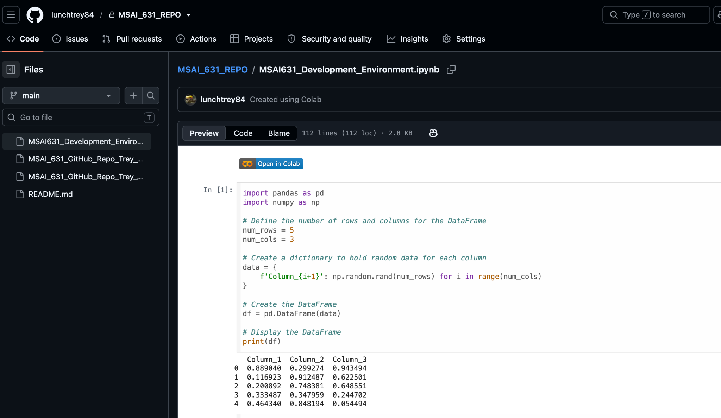
Evaluating Hugging Face as an Alternative
To explore another option, I also attempted to set up a development environment with Hugging Face. I created an account, explored Spaces, and reviewed the platform’s Git functionality, including cloning through HTTPS or SSH and using commit and push commands. Hugging Face was technically capable of supporting the assignment, but the configuration I wanted would have required a paid service, while I already had access to Google’s paid ecosystem. I therefore continued with Google Colab because it better matched my existing resources and workflow. Development teams should focus on the underlying problem rather than becoming committed too early to a predefined solution. In this case, the goal was to create an effective development environment rather than use a specific platform, so selecting Colab was the more practical solution (Kore, 2022).

Reflection
Coding in Google Colab was straightforward because I already had experience with Python and cloud-based AI tools. The most valuable part of the assignment was evaluating how different development environments supported my workflow and identifying the limitations that affected their usability. The GitHub integration issue demonstrated that technical capability alone does not guarantee an effective user experience, while my exploration of Hugging Face showed that multiple platforms can solve the same problem but may introduce different constraints involving access, cost, or configuration. Kore (2022) describes AI development as an iterative and collaborative process that requires experimentation, awareness of system limitations, and continued attention to the user experience. Colab ultimately provided the best combination of functionality, familiarity, and integration for my needs.
Conclusion
I successfully set up Google Colab as the development environment for this exercise and verified that it supports Python development, common libraries, AI-assisted development, and GitHub integration. I also resolved a repository visibility issue and evaluated Hugging Face as an alternative platform before determining that Colab better matched my existing resources and workflow. Effective development depends on experimentation, collaboration, awareness of limitations, and attention to user needs (Kore, 2022). This exercise demonstrated that a successful development environment is defined not only by its technical capabilities but also by how well it supports the user, integrates with other tools, and enables an efficient and iterative development process.
AI Tools and Project Repository Disclosure
I used OpenAI ChatGPT during the development of this project to support brainstorming, code development, and revision of written content. ChatGPT was used as a productivity and development support tool rather than as a replacement for independent analysis or decision-making. I reviewed, tested, verified, and revised all AI-assisted code, and written content included in this project. I accept full responsibility for the accuracy, integrity, and final submitted work.
Project repository: https://github.com/lunchtrey84/MSAI_631_REPO

References
Kore, A. (2022). Designing human-centric AI experiences. Springer Nature. https://reader2.yuzu.com/books/9781484280881

